**Locks technique**

1. **Binary Locks:**
   * A lock that can either be in a locked (1) or unlocked (0) state.
   * If locked, no other transaction can access the resource.
2. **Shared and Exclusive Locks (S-X Locking):**
   * **Shared Lock (S)**: Allows multiple transactions to read the data, but none can write.
   * **Exclusive Lock (X)**: Allows the transaction to both read and write the data item. Only one transaction can hold an exclusive lock on an item at a time.
3. Lock compatibility table->

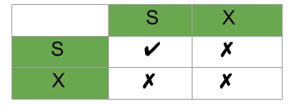

**Two-Phase Locking (2PL):**

* Ensures serializability of transactions by dividing the transaction into two phases:
  1. **Growing Phase**: A transaction can acquire locks but cannot release any.
  2. **Shrinking Phase**: A transaction can release locks but cannot acquire new ones.
* **Strict 2PL**: All locks are held until the transaction commits or aborts, preventing cascading rollbacks.
* **Rigorous 2PL**: Similar to strict 2PL, but all locks (both shared and exclusive) are held until the end of the transaction.

Reference :-

<https://www.geeksforgeeks.org/two-phase-locking-protocol/>